|  |  |
| --- | --- |
| **logo** | **CHALAPATHI INSTITUTE OF ENGINEERING AND TECHNOLOGY**  **Chalapathi Nagar, Lam, Guntur-34** |

**DEPARTMENT OF ELECTRICAL AND ELECTRONICS ENGINEERING**

**Subject: – LINEAR CONTROL SYSTEMS**

|  |  |  |
| --- | --- | --- |
| Faculty Name: K.MURALI KRISHNA RAJU | Year / Sem: B.Tech in EEE 3/1 | Academic Year: 2019-20 |

**Assignment –I**

1. Define and explain open loop and closed loop system with an example?

2. Write the differential equations governing the mechanical rotational system show in fig and determine the transfer function

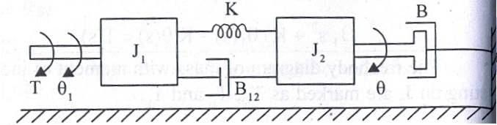

3. Find the transfer function for the sys tem represented by the block diagram show in fig

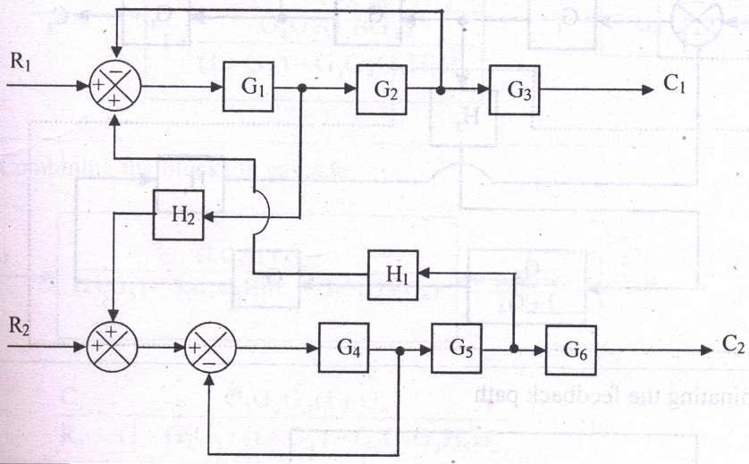

4. Find the overall gain of the system whose signal flow graph is show in fig

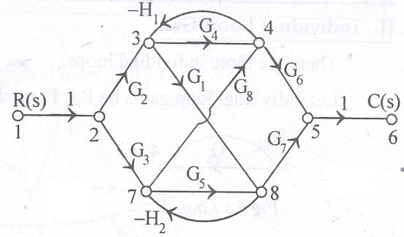

5. Explain the DC servo motor and derive its transfer function

6. Explain the synchro’s pair and derive its transfer function

**Signature of the faculty**

**CHALAPATHI INSTITUTE OF ENGINEERING AND TECHNOLOGY**

|  |  |  |
| --- | --- | --- |
| Class : **III/IV B.Tech** | **I Mid-term Examinations** | Date : 26-08-19 |
| Section **: EEE** | **LINEAR CONTROL SYSTEMS** | Time : **90 Min** |
| Sub Code : **EE 311** |  | Max.Marks :**18** |

**SECTION-A**

**Answer All Questions: (6 x 1 = 6 M)**

1. a) Define Control systems

b) Define electrical Zero position

c) Write Masons Gain Formula.

d) Define Stability.

e) Define Branch, and Node.

f) ) Define Steady State stability.

**SECTION-B**

1. Explain the effect of feedback on overall gain and stability. -6M

**(OR)**

3. Find the transfer function of the control system shown in fig -6M

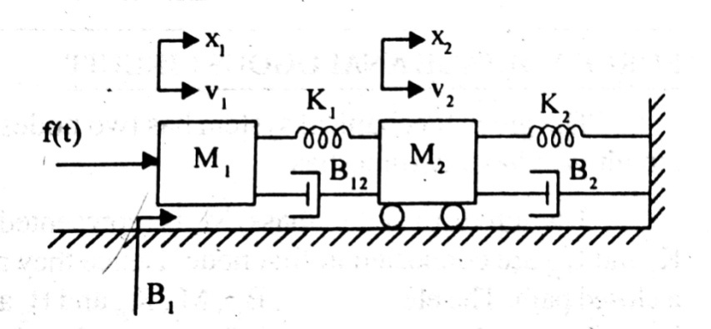

**SECTION-C**

4. Define time response and explain time domain specifications -6M

**(OR)**

5. Find the stability of the system  -6M

**Signature of the faculty**